Project Plan

CareAway Treatment Planner



**Date**: 12/7/2017

**Team Name**: Team Tangent

Eugene Mesina (014455816) Meeting Manager (Team Leader)

Felix Huang (013427386) Documentation Manager

Jimmy Chao (012677182) Accountability Manager

Taylor Tobin (011871260) Technology/Information Manager

Crystal Chun (012680952) Quality Manager

Tyler Dao (013343302) HIPAA Manager

Table of Contents

**Version Control** **2**

**Introduction** **3**

Project Overview 3

**Scope** **4**

Time 4

Specification 5

**Project Resources** **6**

**Project Schedule** **8**

Project SCRUM Description 8

Project Sprint Model 9

List of Deliverables 11

Functional Decomposition 11

Project Timelines 13

Phase Timeline 13

Deadlines 13

Functionalities by Sprint 14

Project Backlog 16

Project Implementation Breakdown 18

Sprint Plans 19

# **Version Control**

|  |  |  |  |
| --- | --- | --- | --- |
| **Revision** | **Revision Date** | **Revisors** | **Description** |
| 1 | 10/5/2017 | Crystal, Eugene | Initial Draft. |
| 2 | 10/9/2017 | Felix, Eugene, Crystal | Final Draft for Milestone 1. Redefined Project Scope. Removed the availability schedule for each member. Updated project timeline with estimations. Revised requirements and finalized tasks needed to accomplish these requirements. |
| 3 | 10/12/2017 | Crystal, Felix | Removed unneeded sections, updated project timeline and added in phases timeline. |
| 4 | 10/15/2017 | Eugene, Crystal, Felix | Added Description and Removed Process Models. Revised Sprint Calendar, Timeline, and Functionality by Sprint. Final Draft. |
| 5 | 10/22/2017 | Crystal | Updated project backlog requirements to match Business Requirements Document and the sprints to match the new backlog. |
| 6 | 11/10/2017 | Crystal | Updated project backlog and sprint boards. |
| 7 | 11/17/2017 | Felix, Crystal | Add Project Plan Scope. Revised sprint boards for updated estimations |

# 

# **Introduction**

## Project Overview

CareAway Treatment Planner is a single page web application for medical professionals and their patients to communicate on the patient’s treatment. The CareAway Treatment Planner will provide tools for medical professionals to oversee their patients’ care through treatment plan creation and treatment feedback. The CareAway Web Application is only meant for medical professionals practicing in the United States of America and their patients who speak and read English.

The CareAway Treatment Planner will be delivered between May 1st, 2017 - May 15th, 2017.

The work that needs to be accomplished to deliver this product with the specified features and functions include:

* Bi-weekly SCRUM meetings to assess project progress
* Designing the product based off of the requirements given by stakeholders
* Building and testing each component of the product
* Incorporating functional and nonfunctional aspects into the final product
* Staying on schedule
* Daily stand-ups

*Minimum Viable Product Description*

* A single page application for desktop browsers that will allow medical professionals to create treatment plans for their patients.
* Patients will be able to interact with their treatment plans and provide feedback to the medical professional.
* Medical professionals will be able to request appointments with patients and/or accept appointment requests from patients. Patients will be able to request appointments with medical professionals and/or accept appointment requests from medical professionals.
* Medical professionals will be able to view and generate data analysis reports.
* The system will be able to support up to 150 users as a baseline - a combination of medical professionals and patients. A medical professional can oversee the care of multiple patients at one time, but the patient can only register themselves to a single medical professional at the time of their registration.
* The system will be able to handle actionable treatment options for the three most common physical (Diabetes, Asthma, and High Blood Pressure) and the three most common mental disorders (Generalized Anxiety Disorder, Panic Disorder, and Social Anxiety Disorder).

# **Scope**

This project plan will describe the work, resources (hardware and software), and time estimations for the CareAway Treatment Planner. Any written deliverables for this project (Business Requirements Document, Project Plan, Technical Design Document, Test Plan, Technology Specification Document) will have a firm delivery date which will be reflected in this project plan. Any estimations, proposed deadlines, and planned implementations specific to the system are based off of the 12 business requirements for the CareAway Treatment Planner from the Business Requirements Document.

## **Time**

The CareAway Treatment Planner will be developed by the six members of Team Tangent. Ideally, each team member will push for 15 hours of work per week. However, since we are assuming an 80% work capacity for each member, we are assuming that at minimum, each member will be committing 12 hours of work per week. The estimations for business requirements and the project as a whole (which is covered later in this document) will be calculated assuming a 12 hour work week for each team member. Each week, the 6 members of Team Tangent will commit in total 72 hours of work per week based on the assumed 12 hour work week for each member.

The development of the CareAway Treatment Planner will be done following the SCRUM methodology. A sprint cycle length is 2 weeks during which the team will be planning, implementing, and testing the solution. Furthermore, the team will be meeting with our client once a week (on some occasions meetings may happen twice a week) to discuss our implementation and gather feedback regarding the status of the project. Daily Stand-Up meetings will be held amongst the members of our team where we will discuss the status of what we are working on and update the team on changes any issues that we are facing during the current sprint.   
  
**Budget**

The projected monetary development cost of the CareAway Treatment Planner will be $0. This projected cost is due to the fact that development for the system will be done using *freeware*, software that is available for use at no monetary cost, MIT licensed software, and services that are free for a limited time. The mentioned freeware and MIT licensed software that will be used include the necessary software for the MEAN stack that will need to be installed on machines along with additional software needed for development such as text editors and testing technologies. The mentioned software that is free for a limited time includes technologies needed for hosting the CareAway Treatment Planner and the subscription to the domain provider.

Furthermore, any hardware that is needed during development or testing, such as computers, mice, and keyboards, will be provided by the members of Team Tangent or will be freely available to access in the Engineering/Computer Sciences computer labs.

Software development of the CareAway Treatment Planner will be done using the MEAN technology stack. The front-end will be developed using Vue.js. The back-end will be developed using Express and NodeJS. A more in-depth explanation of each of these front end frameworks can be found in the Technology Specification Document. Before starting development with this technology stack, each member of the team will use their own personal computer or laptop to install the software for this technology stack that we have chosen.

However, the team may choose to change technologies that we use for implementation. The technologies that we may change to will be listed as alternatives in the Technical Specification Document.

## **Specification**

The CareAway Treatment Planner will be implemented according to specifications as described in the Business Requirements Document. This includes following the functional and nonfunctional requirements for each of the 12 business requirements, ensuring that the implementation adheres to the HIPAA Resolution in the Business Requirements Document, and ensuring that the final implementation fits with the Scope of the Business Requirements Document. Successful implementation of the system will include the following CORE and Content business requirements:

|  |  |
| --- | --- |
| **CORE**   * Data Access * Security * Registration * Authentication/Session Termination * Error Handling * User Management * User Access Control * Network Connectivity | **Content**   * Treatment Plan Creation and Revision * Treatment Plan Interaction * Data Analysis Reports * Appointment Scheduling |

This project plan will only take into account the mentioned business requirements for this implementation of the CareAway Treatment Planner. Each business requirement will organized into a project backlog and will be assigned a priority, or how important a specific business requirement is to the client-specified deliverable. Business requirements will also have an initial estimation for how long they will take to implement and will be reflected accordingly in sprint planning boards.

# **Project Resources**

Team Tangent is composed of six members.

*Staff*

* **Eugene Mesina** - Team Leader and Meeting Manager. Responsibilities include making decisions on behalf of the team and organizing daily stand-up meetings along with weekly meetings with the client.
* **Jimmy Chao** - Accountability Manager. Responsibilities include assigning work to each member of the team, and following up with each member to ensure that work is completed in a timely manner.
* **Taylor Tobin** - Technology/Information Manager. Responsibilities include researching the technology stack, and communicating with the team on how to integrate technology stack into development.
* **Crystal Chun** - Quality Manager. Responsibilities include ensuring the deliverable meets the client’s specification and executing tests from the Test Plan.
* **Tyler Dao** - HIPAA Manager. Responsibilities include researching HIPAA standards and communicating with the team to ensure that decisions and changes to implementation are in line with HIPAA.
* **Felix Huang** - Documentation Manager. Responsibilities include organizing documents, and ensuring that project decisions are accurately reflected in the documents.

*Required Hardware For Development*

* Laptop or Desktop
  + Minimum 2 GB RAM
  + Minimum 1.4 GHz Processor
  + Windows 7 and newer OR Mac OS X El Capitan and newer
  + 10 GB of disk space

*Required Software For Development*

Note: Version numbers for any of the software specified below are taken directly from the Technology Specification Document; in addition, if any of the specified technologies for development below receive an update then the team will update to the latest release.

* **Web Browser** (Google Chrome, Mozilla Firefox, Apple Safari)
  + Cost: Free
  + Availability: Google Chrome v.62.0.3202 is available for Windows 7 and newer and Mac OS X 10.9 Mavericks and newer.  
    **Link**: <https://www.google.com/chrome/browser/desktop/index.html>

Mozilla Firefox v.57.0 is available for Windows 7 and newer and Mac OS X 10.9 Mavericks and newer.

**Link**: <https://www.mozilla.org/en-US/firefox/new/>

Apple Safari v11.0 is available for Mac OS X El Capitan and newer.

* **node package manager** (npm)
  + Cost: Free
  + Availability: npm v5.5.1 is available for modern versions of Windows (Windows 7 and later), Linux (Ubuntu 16.04 and later), and macOS (OS X 10.9 and later).

**Link**: <https://www.npmjs.com/get-npm>

* **GitHub Desktop**
  + Cost: Free
  + Availability: GitHub Desktop v1.0.9 is available on all modern versions of Windows (Windows 7 and later) and macOS (OS X 10.9 and later).  
    **Link:** <https://desktop.github.com>
* **Text Editor** (Visual Studio Code)
  + Cost: Free
  + Availability: Visual Studio Code v.1.18.1 is available on Windows (Windows 7 and later) and macOS (OS X Yosemite and later).

**Link**: <https://code.visualstudio.com/download>

*Required Time Commitment*

Each member of Team Tangent is required to allocate at least 12 hours a week towards the project in order to meet the delivery deadlines. Ideally, each member should be pushing for 15 hours a week, but we are assuming 80% work capacity for each member.

# **Project Schedule**

## Project SCRUM Description

During this process the development team will be following the SCRUM methodology aligned with the Agile software development process. In this plan, the development team has provided estimations of functionalities. Each functionality is organized as a User Story or Epic where each User Story will span the course of one sprint and each Epic will last multiple sprints (2 or more sprints). For this project, a sprint cycle shall last 2 weeks and the **team’s work velocity will be 144 hours per sprint**. At the start of each sprint, sprint planning will occur where tasks and priorities are determined for each User Story and Epic. Tasks should take no longer than 8 - 16 hours in a sprint to complete.

The sprint process begins with developers reviewing the project backlog.Within the time span of a day or two, the team plans out tasks to be completed in the sprint. Team members are assigned a set of tasks to work on during the course of the sprint. In the event that a team member has finished their assigned tasks before the sprint has ended, they will review the project backlog and begin working on tasks for the next requirement that needs to be implemented. During each sprint, there will be daily standups. Standups should be a maximum of 15 minutes and should review what has be done, what will need to be done, and what development blocks are present.

Towards the end of the sprint, there will be 2 - 3 days of retrospectives where the team will spend time to reflect on the sprint to see if there is anything the team or an individual could improve on such as better time estimations, work optimizations, or development practices. Retrospectives should improve the team’s work velocity and future task estimations. Work velocity could increase as experience in the process should lead to greater work output. On the final day of the sprint, the team should have artifacts (deliverables) ready to present. The deliverable must be be tested through the testing methodologies as specified in the Test Plan before it can be deemed an artifact. After these are delivered, the team again reviews the project backlog and assigns tasks and the process starts again.

## Project Sprint Model

**Project Sprint Model Activity Definitions**

**Backlog Grooming** - At the start of each sprint, the team will review the project backlog. Work that has been completed will be removed from the backlog. Priority for each business requirement will be rearranged.

**Sprint Planning** - Before the implementation phase, the team will determine which business requirements will be worked on during the sprint. Tasks will be assigned to each member to work on.

**Implementation** - The team works on their assigned task for the sprint.

**Testing** - After the implementation phase, the team should have some deliverable. However, before this deliverable can be brought to the client, it must undergo testing. Testing will be limited to the methodologies described in the Test Plan.

**Daily Standup** - During the course of a sprint, each the team will have a short daily meeting. In this meeting, each member will talk about (1) what they accomplished yesterday (2) what they will be doing today (3) any roadblocks that they are experiencing.

**Stand-Up Meeting with Client** - Each week, the team will meet once ( and on some occasions twice) with the client. During this meeting, the team will talk to the client and update him on the progress that has been made since the last meeting and what work will be done in the coming week. The team will also ask for client feedback on deliverables.

**Team Meeting** - The team will have a formal meeting twice a week. All members are required to be present for this meeting. During this meeting, the team will discuss work relating to implementation and members may ask for clarification about anything they are confused on.

**Retrospective** - Before the sprint ends, each member will take time to reflect on the work they have done during the course of the sprint. Members may review the work they have done and determine if they can improve on it.

**Artifact** - At the end of the sprint, the team should have some deliverables that have been properly implemented and tested. These deliverables will be presented to the client during the next meeting.

*Framework Activities - Software development activities that are carried out to ensure development is going smoothly and to the customer’s specification.*

* Customer Communication: Reaching out to the customer and having discussions about the progress of the project and getting the customer’s feedback on the project. Communication with the customer includes in-person meetings and e-mail.
* Planning/Design: Going through each functionality and mapping out how each will be handled, what it will look like, etc.
* Implementation: Executing the designs and plans into code.
* Testing: Executing tests for each component and making sure the component does what it is intended and meets customer specifications. Tests for each component are specified in the Test Plan.
* Customer Evaluation: Receiving customer’s feedback on the completed project.

*Task Set - required implementation tasks to deliver a product that meets customer’s specification.*

* Requirements Specification: Determine what the client wants built, why they want it built, and what they hope the system will be able to accomplish.
* Interface Construction: Design the UI for the landing page and user accessible pages (treatment plan calendar, widgets, appointments, Data Analysis Reports)
* Server Construction: Communicate with the front-end designer about what data will be transferred between the client and the server and handle those connections appropriately. Setup database access and manipulation. Setup the backend logic.
* Database Construction: Create the database that will be needed to store user data.
* Testing: Perform verification and validation testing. As each component is built, execute instructions in the Test Plan to ensure the component behaves correctly. Compare the implemented component with the Business Requirements Document to ensure that it meets the client’s specifications.

## 

## 

## 

## List of Deliverables

*Documentation*

* Project Proposal
* Weekly Standup Documents
* Business Requirements Document
* Project Plan
* Technical Specification Document
* Design Document
* Test Plan

## Functional Decomposition

*Interface Task Breakdown*

* CareAway Homepage - The homepage of the application when the user is not authenticated into the system.
* Authentication view - The page the user utilizes to access the application.
* Reset Credentials view - The page where the user can reset their credentials.
* Patient Registration view - The page a new patient uses to create an account for the application.
* Medical Professional Registration view - The page a new medical professional uses to create an account for the application.
* System Administrator Account view - The page the system administrator first sees when they login. This page should show an option to notify users of a breach.
* Patient Account (Treatment Plan) view - The page the patient first sees when they login. The page should show a treatment plan created by the medical professional. If a treatment plan has not been created, the treatment plan should be empty.
* Medical Professional Account (Appointment Page) view - The page the medical professional first sees when they login. The page shows a calendar for upcoming appointments, their medical professional registration code, along with options to select a patient, request appointments, and generate data analysis reports.
* Patient’s Treatment view - The page a medical professional will interact with to create the patient treatment plan.
* Data Analysis Report view - The page a medical professional will use to view the data analysis report of a particular patient and a particular diagnosis.

*Testing Task Breakdown*

* End-to-end & Validation testing - Testing to ensure a component behaves correctly from beginning to end, and to ensure the component fulfills the business requirements laid out for it.
* Unit testing - Each component is tested in isolation as it is being developed.
* Regression testing - If a component undergoes a change during development, regression testing is done to ensure proper functionality.
* Smoke testing - Testing done when the system has been fully created to ensure proper functionality of all of its integrated components.

## 

## 

## Project Timelines

### Phase Timeline

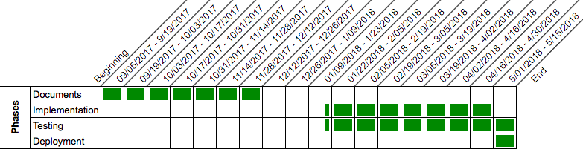

### Deadlines

The chart below shows the requirements due on the specified date.

### 

### 

### Functionalities by Sprint

The charts below show during which sprint each functionalities’ user story will be implemented.

*Chart 1, sprints 1 through 4*

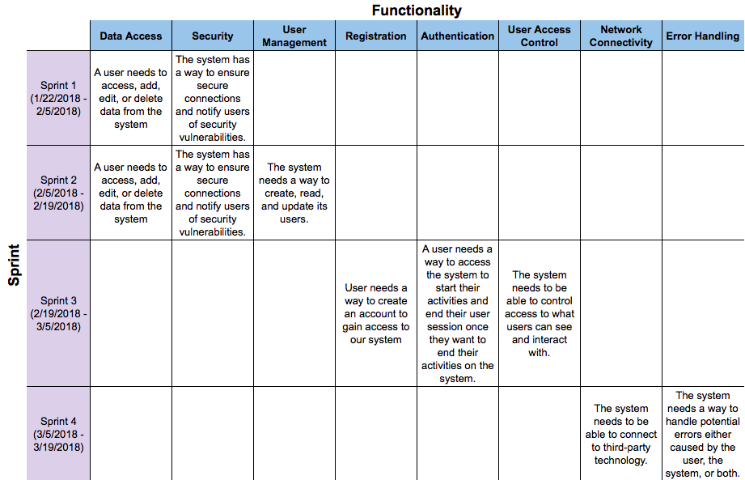

*Chart 2, sprints 5 through 8*

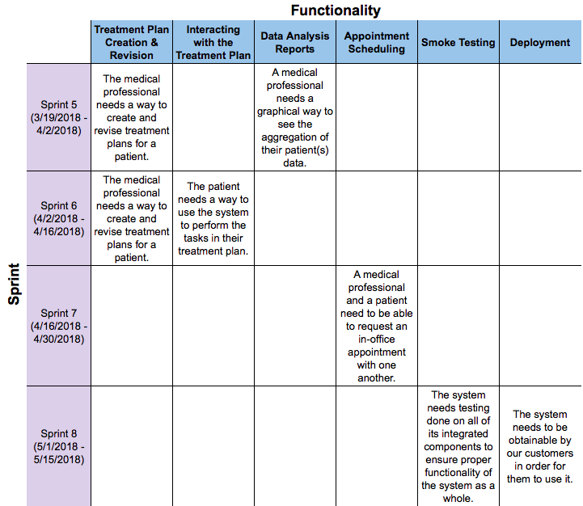

## 

## 

## Project Backlog

*Complexity levels:*

Low (1 week for completion)

Medium (1 - 2 weeks for completion)

High (2 - 3 weeks for completion)

|  |  |  |
| --- | --- | --- |
| **Work Item** | **Priority** | **Complexity** |
| Business Requirements Document | 1 | High |
| Project Plan | 2 | Medium |
| Technical Specification Document | 3 | Low |
| Design Document | 4 | Medium |
| Test Plan | 5 | High |
| Data Access | 6 | High |
| Security | 7 | High |
| User Management | 8 | Medium |
| Registration | 9 | Medium |
| Authentication/Session Termination | 10 | Medium |
| User Access Control | 11 | Medium |
| Error Handling | 12 | Low |
| Network Connectivity | 13 | Low |
| Treatment Plan Creation and Revision | 14 | High |
| Interacting with Treatment Plan | 15 | Medium |
| Data Analysis Report | 16 | Low |
| Appointment Scheduling | 17 | Low |

Each requirement for this project was categorized by complexity into **High**, **Medium**, and **Low** categories in the project backlog.

For **High** requirements, we estimated it will take 2 - 3 weeks to complete.

For **Medium** requirements, we estimated it will take 1 - 2 weeks to complete.

For **Low** requirements, we estimated it will take 1 week to complete.

Each requirement for this project was also given a **Priority**, a numerical indicator of how important the requirement is to the deliverable. Requirements with high priority have a higher level of importance to the overall system than those with low priority, and will be given attention first during implementation.

## 

## 

## Project Implementation Breakdown

**CORE requirements** (67%)

* Data Access
* Security
* User Management
* Registration
* Authentication/Session Termination
* User Access Control
* Error Handling
* Network Communication

**Content requirements** (33%)

* Treatment Plan Creation and Revision
* Interacting with Treatment Plan
* Data Analysis Report
* Appointment Scheduling

**Time Estimation:**

For our project estimations, we are projecting 12 hours of work per week for each member of our team. By using the scale at the top of this page, the team has estimated total number of weeks needed to implement each CORE and Content requirements. The team then converted the estimated weeks for each requirement into hours by multiplying by 72 (the total number of work hours for the team in a week). The sum of these hours gives us the total estimated time (in hours) to complete the project. These estimations also take into account that requirements for this project will be handled concurrently meaning that more than one business requirement could be worked on by different team members during the course of a sprint.

Lastly, the team will utilize the final sprint before the semester ends for deployment activities - deploying the application onto the hosting service and performing smoke testing.

*Total CORE requirements estimation*: **1066** hours

*Total Content requirements estimation*: **504** hours

*Total Project estimation*: **1570** hours

## 

## 

## Sprint Plans

**Sprint 0**

*9/5/2017 - 12/7/2017*

|  |  |  |  |
| --- | --- | --- | --- |
| **Work** | **Resource(s)** | **Estimation** | **Complexity** |
| Business Requirements Document | Jimmy | 3 weeks | High |
| Business Requirements Document | Felix | 3 weeks | High |
| Business Requirements Document | Tyler | 3 weeks | High |
| Project Plan | Crystal | 2 weeks | Medium |
| Project Plan | Felix | 2 weeks | Medium |
| Project Plan | Eugene | 2 weeks | Medium |
| Technical Specification Document | Eugene | 1 week | Low |
| Technical Specification Document | Jimmy | 1 week | Low |
| Technical Specification Document | Crystal | 1 week | Low |
| Technical Specification Document | Tyler | 1 week | Low |
| Test Plan | Tyler | 3 weeks | High |
| Test Plan | Jimmy | 3 weeks | High |
| Test Plan | Felix | 3 weeks | High |
| Design Document | Taylor | 2 weeks | Medium |
| Design Document | Eugene | 2 weeks | Medium |
| Design Document | Tyler | 2 weeks | Medium |

**Sprint 1**

*1/22/2018 - 2/5/2018*

|  |  |  |  |
| --- | --- | --- | --- |
| **Work** | **Resource(s)** | **Estimation** | **Complexity** |
| Security | Crystal | 3 weeks | High |
| Data Access | Jimmy | 3 weeks | High |
| Data Access | Felix | 3 weeks | High |
| Security | Taylor | 3 weeks | High |
| Security | Eugene | 3 weeks | High |
| Data Access | Tyler | 3 weeks | High |

**Sprint 2**

*2/5/2018 - 2/19/2018*

|  |  |  |  |
| --- | --- | --- | --- |
| **Work** | **Resource(s)** | **Estimation** | **Complexity** |
| Security | Crystal | 3 weeks | High |
| Data Access | Jimmy | 3 weeks | High |
| Data Access | Felix | 3 weeks | High |
| User Management | Taylor | 2 weeks | Medium |
| Security | Eugene | 3 weeks | High |
| User Management | Tyler | 2 weeks | Medium |

**Sprint 3**

*2/19/2018 - 3/5/2018*

|  |  |  |  |
| --- | --- | --- | --- |
| **Work** | **Resource(s)** | **Estimation** | **Complexity** |
| Registration | Crystal | 2 weeks | Medium |
| Authentication | Jimmy | 2 weeks | Medium |
| Authentication | Felix | 2 weeks | Medium |
| Registration | Taylor | 2 weeks | Medium |
| User Access Control | Eugene | 2 weeks | Medium |
| User Access Control | Tyler | 2 weeks | Medium |

**Sprint 4**

*3/5/2018 - 3/19/2018*

|  |  |  |  |
| --- | --- | --- | --- |
| **Work** | **Resource(s)** | **Estimation** | **Complexity** |
| Network Connectivity | Crystal | 1 week | Low |
| Error Handling | Jimmy | 1 week | Low |
| Error Handling | Felix | 1 week | Low |
| Error Handling | Taylor | 1 week | Low |
| Network Connectivity | Eugene | 1 week | Low |
| Network Connectivity | Tyler | 1 week | Low |

**Sprint 5**

*3/19/2018 - 4/2/2018*

|  |  |  |  |
| --- | --- | --- | --- |
| **Work** | **Resource(s)** | **Estimation** | **Complexity** |
| Treatment Plan Creation & Revision | Taylor | 3 weeks | High |
| Treatment Plan Creation & Revision | Eugene | 3 weeks | High |
| Treatment Plan Creation & Revision | Tyler | 3 weeks | High |
| Data Analysis Reports | Felix | 1 week | Low |
| Data Analysis Reports | Crystal | 1 week | Low |
| Data Analysis Reports | Jimmy | 1 week | Low |

**Sprint 6**

*4/2/2018 - 4/16/2018*

|  |  |  |  |
| --- | --- | --- | --- |
| **Work** | **Resource(s)** | **Estimation** | **Complexity** |
| Treatment Plan Creation & Revision | Taylor | 3 weeks | High |
| Interacting with Treatment Plan | Crystal | 2 weeks | Medium |
| Treatment Plan Creation & Revision | Tyler | 3 weeks | High |
| Interacting with Treatment Plan | Felix | 2 weeks | Medium |
| Treatment Plan Creation & Revision | Eugene | 3 weeks | High |
| Interacting with Treatment Plan | Jimmy | 2 weeks | Medium |

**Sprint 7**

*4/16/2018 - 4/30/2018*

|  |  |  |  |
| --- | --- | --- | --- |
| **Work** | **Resource(s)** | **Estimation** | **Complexity** |
| Appointment Scheduling | Taylor | 1 week | Low |
| Appointment Scheduling | Crystal | 1 week | Low |
| Appointment Scheduling | Tyler | 1 week | Low |
| Appointment Scheduling | Eugene | 1 week | Low |
| Appointment Scheduling | Felix | 1 week | Low |
| Appointment Scheduling | Jimmy | 1 week | Low |

**Sprint 8**

*5/1/2018 - 5/15/2018*

|  |  |  |  |
| --- | --- | --- | --- |
| **Work** | **Resource(s)** | **Estimation** | **Complexity** |
| Smoke Testing | Taylor | 1 week | Low |
| Deployment | Crystal | 2 weeks | High |
| Deployment | Tyler | 2 weeks | High |
| Deployment | Eugene | 2 weeks | High |
| Smoke Testing | Felix | 1 week | Low |
| Smoke Testing | Jimmy | 1 week | Low |